TRILOGY - CELEBRITY OF THE WEEK : Rowan Atkinson EXAMPLE
British actor, screen writer , comedian

Studied in Oxford (degrees in electrical engineering)
4 brothers
Wife – Sunetra Sastry
2 children – Benjamin / Lily

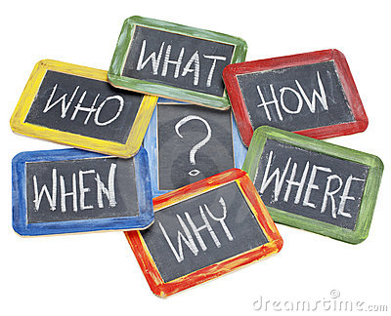

Born on January 6th, 1955
Married in 1990
Born in England
Mainly popular in the UK

1st – Radio,
2nd - 4 weddings & 1 funeral, Love Actually, Johnny English.
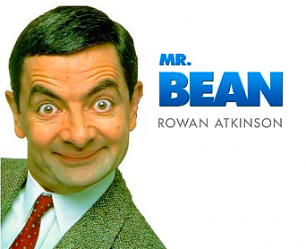

Extra – Information (tastes, anecdotes, …)
cars
Opening ceremony – London 2012

TRILOGY - CELEBRITY OF THE WEEK : Rowan Atkinson EXAMPLE
British actor, screen writer , comedian

Studied in Oxford (degrees in electrical engineering)
4 brothers
Wife – Sunetra Sastry
2 children – Benjamin / Lily

Born on January 6th, 1955
Married in 1990
Born in England
Mainly popular in the UK

1st – Radio,
2nd - 4 weddings & 1 funeral, Love Actually, Johnny English.

Extra – Information (tastes, anecdotes, …)
cars
Opening ceremony – London 2012

TRILOGY - CELEBRITY OF THE WEEK : Rowan Atkinson EXAMPLE
British actor, screen writer , comedian

Studied in Oxford (degrees in electrical engineering)
4 brothers
Wife – Sunetra Sastry
2 children – Benjamin / Lily

Born on January 6th, 1955
Married in 1990
Born in England
Mainly popular in the UK

1st – Radio,
2nd - 4 weddings & 1 funeral, Love Actually, Johnny English.

Extra – Information (tastes, anecdotes, …)
cars
Opening ceremony – London 2012

TRILOGY - CELEBRITY OF THE WEEK : Rowan Atkinson EXAMPLE
British actor, screen writer , comedian

Studied in Oxford (degrees in electrical engineering)
4 brothers
Wife – Sunetra Sastry
2 children – Benjamin / Lily

Born on January 6th, 1955
Married in 1990
Born in England
Mainly popular in the UK

1st – Radio,
2nd - 4 weddings & 1 funeral, Love Actually, Johnny English.

Extra – Information (tastes, anecdotes, …)
cars
Opening ceremony – London 2012

TRILOGY - CELEBRITY OF THE WEEK : ___________________________

No sentences,
just notes.
Don’t forget to bring a picture!
Extra – Information (tastes, anecdotes, …)

TRILOGY - CELEBRITY OF THE WEEK : ___________________________

No sentences,
just notes.
Don’t forget to bring a picture!
Extra – Information (tastes, anecdotes, …)

