TRILOGY - WORD OF THE DAY : Anchor Pronunciation : [ ˈæŋ.kər] EXAMPLE
heavy metal object

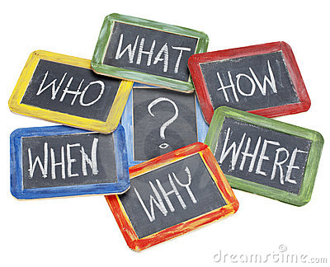
sailors
shape - cross with curved arms

to stop the boat
rope / chain
dropped from boat / water

Extra – Information (opinion, example, references…)
Ferry (Southampton) every day
symbol of the Navy (tattoo) + Captain Haddock
prevent the vessel from moving away
(current / wind)

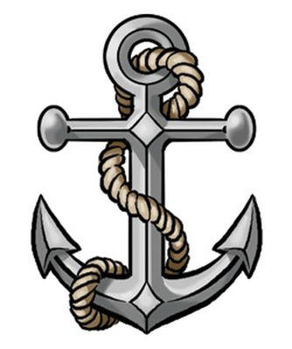
An anchor is a heavy metal object, usually shaped like a cross with curved arms, on a strong rope or chain, which is dropped from a boat or a ship into the water to prevent the vessel from moving away because of the wind or the current. It is used by sailors when they want to stop a boat for a short or long time. About my personal experience, I have already seen an anchor on a ferry boat, but it is not something we can see every day. More generally, it is best known as the symbol of the Navy. In addition to say, anchor tattoo designs are one of the oldest types of tattoos. To conclude, I guess the most famous anchor is the one which is on the cap of Captain Haddock.

TRILOGY - WORD OF THE DAY : Anchor Pronunciation : [ ˈæŋ.kər] EXAMPLE
heavy metal object

sailors
shape - cross with curved arms

to stop the boat
rope / chain
dropped from boat / water

Extra – Information (opinion, example, references…)
Ferry (Southampton) every day
symbol of the Navy (tattoo) + Captain Haddock
prevent the vessel from moving away
(current / wind)

An anchor is a heavy metal object, usually shaped like a cross with curved arms, on a strong rope or chain, which is dropped from a boat or a ship into the water to prevent the vessel from moving away because of the wind or the current. It is used by sailors when they want to stop a boat for a short or long time. About my personal experience, I have already seen an anchor on a ferry boat, but it is not something we can see every day. More generally, it is best known as the symbol of the Navy. In addition to say, anchor tattoo designs are one of the oldest types of tattoos. To conclude, I guess the most famous anchor is the one which is on the cap of Captain Haddock.

TRILOGY - WORD OF THE DAY : Anchor Pronunciation : [ ˈæŋ.kər] EXAMPLE
heavy metal object

sailors
shape - cross with curved arms

to stop the boat
rope / chain
dropped from boat / water

Extra – Information (opinion, example, references…)
Ferry (Southampton) every day
symbol of the Navy (tattoo) + Captain Haddock
prevent the vessel from moving away
(current / wind)

An anchor is a heavy metal object, usually shaped like a cross with curved arms, on a strong rope or chain, which is dropped from a boat or a ship into the water to prevent the vessel from moving away because of the wind or the current. It is used by sailors when they want to stop a boat for a short or long time. About my personal experience, I have already seen an anchor on a ferry boat, but it is not something we can see every day. More generally, it is best known as the symbol of the Navy. In addition to say, anchor tattoo designs are one of the oldest types of tattoos. To conclude, I guess the most famous anchor is the one which is on the cap of Captain Haddock.

TRILOGY - WORD OF THE DAY : Anchor Pronunciation : [ ˈæŋ.kər] EXAMPLE
heavy metal object

sailors
shape - cross with curved arms

to stop the boat
rope / chain
dropped from boat / water

Extra – Information (opinion, example, references…)
Ferry (Southampton) every day
symbol of the Navy (tattoo) + Captain Haddock
prevent the vessel from moving away
(current / wind)

An anchor is a heavy metal object, usually shaped like a cross with curved arms, on a strong rope or chain, which is dropped from a boat or a ship into the water to prevent the vessel from moving away because of the wind or the current. It is used by sailors when they want to stop a boat for a short or long time. About my personal experience, I have already seen an anchor on a ferry boat, but it is not something we can see every day. More generally, it is best known as the symbol of the Navy. In addition to say, anchor tattoo designs are one of the oldest types of tattoos. To conclude, I guess the most famous anchor is the one which is on the cap of Captain Haddock.

TRILOGY - WORD OF THE DAY : ___________________________ Pronunciation : [ _______________ ]

No sentences,
just notes.
Don’t forget to bring a picture!
Extra – Information (opinion, example, references…)

TRILOGY - WORD OF THE DAY : ___________________________ Pronunciation : [ _______________ ]

No sentences,
just notes.
Don’t forget to bring a picture!
Extra – Information (opinion, example, references…)

TRILOGY - Example of word of the day.
An anchor is a heavy metal object, usually shaped like a cross with curved arms, on a strong rope or chain, which is dropped from a boat or a ship into the water to prevent the vessel from moving away because of the wind or the current. It is used by sailors when they want to stop a boat for a short or long time. About my personal experience, I have already seen an anchor on a ferry boat, but it is not something we can see every day. More generally, it is best known as the symbol of the Navy. In addition to say, anchor tattoo designs are one of the oldest types of tattoos. To conclude, I guess the most famous anchor is the one which is on the cap of Captain Haddock.

TRILOGY - Example of word of the day.
An anchor is a heavy metal object, usually shaped like a cross with curved arms, on a strong rope or chain, which is dropped from a boat or a ship into the water to prevent the vessel from moving away because of the wind or the current. It is used by sailors when they want to stop a boat for a short or long time. About my personal experience, I have already seen an anchor on a ferry boat, but it is not something we can see every day. More generally, it is best known as the symbol of the Navy. In addition to say, anchor tattoo designs are one of the oldest types of tattoos. To conclude, I guess the most famous anchor is the one which is on the cap of Captain Haddock.

TRILOGY - Example of word of the day.
An anchor is a heavy metal object, usually shaped like a cross with curved arms, on a strong rope or chain, which is dropped from a boat or a ship into the water to prevent the vessel from moving away because of the wind or the current. It is used by sailors when they want to stop a boat for a short or long time. About my personal experience, I have already seen an anchor on a ferry boat, but it is not something we can see every day. More generally, it is best known as the symbol of the Navy. In addition to say, anchor tattoo designs are one of the oldest types of tattoos. To conclude, I guess the most famous anchor is the one which is on the cap of Captain Haddock.

TRILOGY - Example of word of the day.
An anchor is a heavy metal object, usually shaped like a cross with curved arms, on a strong rope or chain, which is dropped from a boat or a ship into the water to prevent the vessel from moving away because of the wind or the current. It is used by sailors when they want to stop a boat for a short or long time. About my personal experience, I have already seen an anchor on a ferry boat, but it is not something we can see every day. More generally, it is best known as the symbol of the Navy. In addition to say, anchor tattoo designs are one of the oldest types of tattoos. To conclude, I guess the most famous anchor is the one which is on the cap of Captain Haddock.

TRILOGY - Example of word of the day.
An anchor is a heavy metal object, usually shaped like a cross with curved arms, on a strong rope or chain, which is dropped from a boat or a ship into the water to prevent the vessel from moving away because of the wind or the current. It is used by sailors when they want to stop a boat for a short or long time. About my personal experience, I have already seen an anchor on a ferry boat, but it is not something we can see every day. More generally, it is best known as the symbol of the Navy. In addition to say, anchor tattoo designs are one of the oldest types of tattoos. To conclude, I guess the most famous anchor is the one which is on the cap of Captain Haddock.

AN ANCHOR AN ANCHOR AN ANCHOR

